Canaima, Venezuela
January, 1990
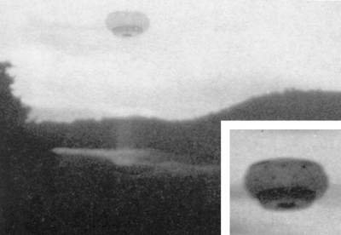
description:
Some photographs have been confirming mutiple witness UFO visual observations. This particular picture has also another interest: it shows seemingly the same type of UFO than those seen on the controversial photographs at Gulfe Breeze, USA, by Ed Walters.
CANAIMA, VENEZUELA, 1990:
This photograph has been taken at Canaima, Venezuela, in January 1990. Just after the photograph was taken, the object became orange and luminous and shot upwards in the sky.
Source: UFOs at Close Sight (Patrick Gross)
Original

