Burbank, California, USA
June, 1945
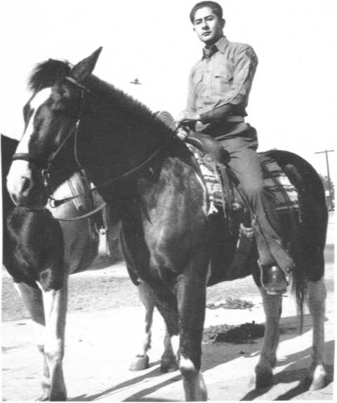
description:
Jack LeMonde UFO Picture
Taken in Burbank, CA in 1945 At Pickwick Riding stables. Look at sky background between horses neck and subjects face.
--------------------------------
1945 Jack LeMonde UFO Photo Analysis
John Alexander, NIDS (National Institute of Discovery Science)
http://www.nidsci.org/news/lemonde.html
In late February 2000, Peter Gersten contacted me about a UFO photo that had been posted on the CAUS website. The person in the picture was in a military uniform and he wanted to know what I thought about the photo. Intrigued, I had Peter help me contact the owner of the photo, as the name provided is a pseudonym.
After exchanging several e-mails, Jack LeMonde agreed to a personal meeting near his home. On 9 March the meeting took place. When I asked about obtaining a copy of the print, LeMonde stated that he had checked me out and was prepared to temporarily loan me the original contact print for examination. What follows are the results of that examination and background information about the photo.
According to LeMonde, the photo was taken on a June morning in 1945. He is the individual sitting on the horse. Twice wounded while fighting with the U.S. Marine Corps in the South Pacific, he was then home on leave. The exact date is not known but the location is near the Pickwick Riding stables in Burbank, California. In those days this was a relatively rural area and equestrian stables were common. The photographer was his father, a motion picture producer with extensive technical experience.
The camera belonged to LeMonde himself. Like his father, he too had a keen interest in photography and owned very good equipment. The camera was a German Voightlander equipped with a Carl Zeiss f3.5 lens (possibly f4.5) with a focal length of approximately 10 centimeters. It is the excellent quality of the optics that made this remarkable photo possible. LeMonde believes the f-stop was set at f-11 with shutter speed at 1/50th of a second. LeMonde emphasized that the f-stop and shutter speed were from memory-going back over 50 years. The film was standard Kodak 120 with an ASA of 25.
When the film was developed they noticed the unusual object above the horse's neck. It was attributed to either an airplane in the distance or a speck of dust that had gotten on the negative. Remember, in 1945 the words flying saucer did not exist. Therefore, it is highly unlikely that LeMonde was hoaxing something that was totally unknown. Photo #1 is the original of LeMonde on his horse. The UFO is clearly visible between him and the horse's neck. Photo #2 is an enlargement showing the UFO in greater detail.
The family placed the supposedly blemished photo in the family album where it remained for more than 50 years. Upon the death of LeMonde's father, several members of the family expressed interest in obtaining copies of the family pictures. Having had a technical career, LeMonde had both the experience and the equipment to digitize the photos so that all family members desiring them could have a copy. When he began to scan this photo he again noticed the blemish and decided to enlarge that section. In so doing he discovered it was in fact a UFO. Unfortunately, after 50 plus years the negative is missing.
In researching the dating of photos I learned it is nearly impossible to authenticate the paper. To assist in this process I contacted a retired member of the FBI's Special Photographic Unit and he provided instructions on how to proceed. He noted that the basic historical databases and paper archives do not exist. The best that can be done is to test the chemical emulsions on the photo. This is a destructive test and would require most of the existing photo. Unwilling to destroy the photo we were left with traditional methods that includes physical examination for anachronistic anomalies. None were found. Further, as LeMonde was in the photo, I was able to look at several pictures taken over time and am convinced that this is the same person.
The next step was to enlist the aid of Peter Stankiewicz, a former technical photographer and photo analyst for the U.S. Air Force. He currently manages the largest photographic laboratory in Las Vegas. Stankiewicz and I examined the original print under a microscope. He then digitized the versions in this article and analyzed them. The original photo was a 2¼ by 3¼ inches contact print. All aspects of the lighting angles and intensity appear to be congruent. Taken to the grain level under a microscope there is no indication of a supporting structure of any kind. The clarity of the object suggests this is not an item that had been thrown into the air. At the shutter speed listed, a thrown object would be slightly blurred. A fair amount of structure can been seen on the object. All indications are that the photograph was developed at about the time reported (1945).
Since too many original items associated with aerial phenomena disappear, the original contact print has been returned to LeMonde. In fact, I made a second trip so that I could personally return the original photograph to him. We have also searched the UFO archives looking for a craft with the same physical characteristics. One of the better examples is posted with this article as Photo #3. This photo was provided to me by Michael Hesemann and taken from a book published in Germany. The photo is one frame from a motion picture reportedly taken 23 July 1966 near Clarksburg, West Virginia. According to the text, two men were driving on a country road when they spotted a UFO following them. They had two brief opportunities to take home movies of it. They estimated the craft to be 3.6 meters in diameter and reported a humming sound as they filmed.
It should be noted that no attempt has been made to authenticate Photo #3. Rather, it is included because of the structural similarity to the photo taken in 1945.
In my contacts with LeMonde I found him to be honest and straightforward. When I offered to pay to have a reproduction made he refused. LeMonde noted that obtaining any money for this photograph would contaminate the authenticity. He has asked for nothing in return for the picture and is only interested in providing the information to the public. Because of his professional background he has chosen to remain anonymous. I have seen sufficient evidence to confirm the authenticity of his career and respect his desires not to become involved in a UFO controversy. To the best of my knowledge, LeMonde has provided the first known authentic picture of a UFO.
----------------------
Is The LeMonde UFO A Light Fixture?
by John Alexander
NIDS has received several responses to the LeMonde photo suggesting that the object is a street light fixture of some kind. That seemingly simple answer was rejected for several reasons. Each response indicated that the light was suspended on a wire. As stated in the article, microscopic examination of the photo down to the gain level failed to reveal any suspending or supporting mechanisms. Further, behind the horse's neck, close to the saddle can be seen the curved arches of a sign that is over a drive-in movie theater. That provides a reference for height. The object in question is well in the background behind the marquee. The distance infers that the object is much larger than a street light and substantially higher. Were it small and in the foreground, the supporting mechanism would be observable. It is not.
In checking on street lighting in Burbank in 1945 it was determined that the lights describe by those who "instantly recognized" the object in the photo were not in use in that community. Rather, the existing streetlights were placed atop granitized concrete posts. No such post is visible. Also, the lamp itself was a totally different variety.
Actually, when LeMonde first provide me the picture he stated that he estimated the height of the object to be between 750-850 feet above the ground. That figure was derived based on the photographic angle and as he believed the object was over two miles away. I am not as convinced that the object is that far away or that it is over 700 feet high. However, it is well above normal street light heights. (LeMonde now believes the object was probably about a mile away.) It is a solid object.
There have also been suggestions that the photograph had been manipulated. You are viewing a digitized version. We worked from the first generation contact print. Blemishes, including dust, were intentionally included so that we can claim the no alteration has been made. Again, microscopic examination of the contact print failed to reveal any irregularities. Were this picture taken today, given the advances in photographic technology, it would be nearly meaningless. That is why we spent a great deal of effort attempting to authenticate the age of the print. Short of destroying the picture, something neither LeMonde nor we are prepared to do, there are no other means of dating available. We believe the date to be reasonably accurate.
Questions have been raised about why LeMonde did not seize upon this UFO sighting in 1947 when the issue was first raised. There were other things going on when the picture was taken. Like World War II. Remember LeMonde had been wounded twice fighting with the U.S. Marines in the South Pacific and had been overseas for three years. Lost to most Americans is that we were planning a ground invasion of Japan and he probably would have been involved in that action. His unit was scheduled to land at Sasebo Harbor on the island of Honshu. Until the bombings of Hiroshima and Nagasaki it was anticipated that that attacking Japan proper would be a very bloody and unpleasant experience. Clearly, he had far more to be concerned about than remembering a blemish on one of the pictures of him.
Source: NIDS (National Institute for Discovery Science) / CAUS (Citizens Against UFO Secrecy)
Original source webpage / article

