Brunchillii, N. Australia
March 28, 1992
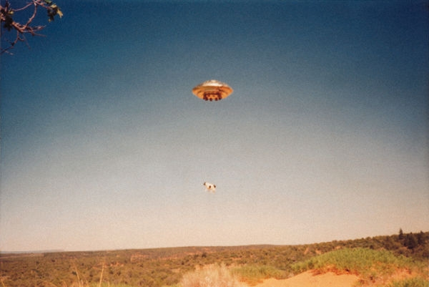
description:
Brunchillii, N. Australia. March 28, 1992
Neil Godfried
"Reality is only what one accepts. It's hard for one to accept that which they fear. What is the opposite of reality? Welcome to my world...
Put that in your pipe and smoke it. I'm going to bed." Neil Godfried
(El Disco)
Source: El Disco
Original source

