Brownstown, Illinois, USA
January 5, 1975
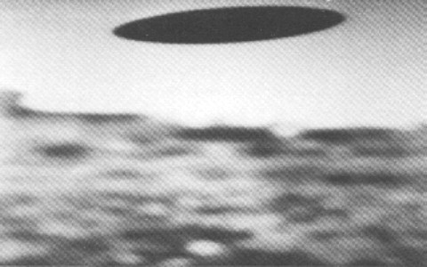
description:
Source:
Original source webpage / article

