Bogadinski, Kazakhstan
April 27, 1995
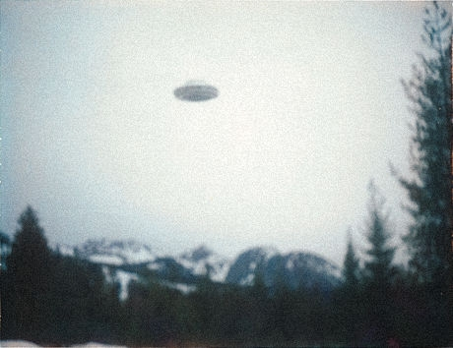
description:
Picture by amateur in former USSR
Kazakhstan, 1995:
A picture taken by Semyon Teglyov in the region of Bogadinski, Kazakhstan, on April 27, 1995.
Source: UFOs at Close Sight (Patrick Gross)
Original source webpage / article

