NAVIGATION MENU Photo 6 of 176
FIRST | PREVIOUS | NEXT | LAST

Baghdad, Arizona
October 19, 2003
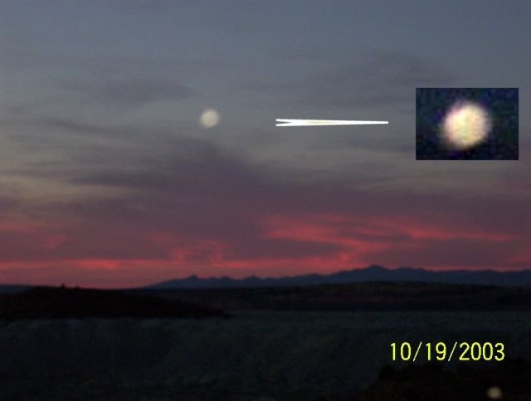
description:
The following photograph was taken by Gerald Bringle at sunset around 7 PM on October 19, 2003 over Baghdad, Arizona. Gerald says the UFO just rushed toward him, then suddenly disappeared.
Source: UFO Casebook
Original source webpage / article

FAIR USE NOTICE: This page contains copyrighted material the use of which has not been specifically authorized by the copyright owner. This website distributes this material without profit to those who have expressed a prior interest in receiving the included information for research and educational purposes. We believe this constitutes a fair use of any such copyrighted material as provided for in 17 U.S.C § 107.

