Australia
2002
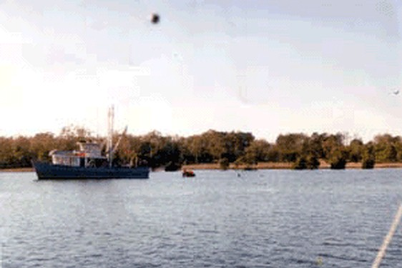
description:
Elaine from Burnett Heads, dropped into the ABC Wide Bay studios with a photo she took in winter, 2002.
Elaine's UFO story
"We were on our yacht, moored at the marina near Burnett Heads.
"It was about mid morning last year, during winter. The TAFE training vessel was out on the water with a lot of people on it. They were obviously doing a practise run on how to jump into a life raft; about six at a time were jumping in at a time.
"So I was taking photos thinking this was an interesting exercise that you don't see often. My husband and I probably took five photos or so over an hour during their training.
"When we got the photos back one had a round thing in the picture that we couldn't explain!
"Before this photo, I had never seen UFOs. I must say that now my mind is open to the idea of a UFO," said Elaine.
"I've shown lots of people who said it must have been a spot on the lens or the negative, but none of the other photos had it, and it doesn't look like a mark or a spot, it's quite round," she said.
Source: ABC Wide Bay, Queensland, Australia / UFO Casebook
Original source webpage / article

