Armagosa Range, California, USA
July 6, 1996
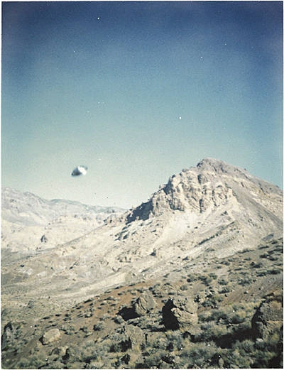
description:
Armagosa Range, CA. July 6, 1996
Jim W.
"Please withold my e-mail address, thank you." Jim W.
Source: El Disco

