Arizona, USA
April 13, 1997
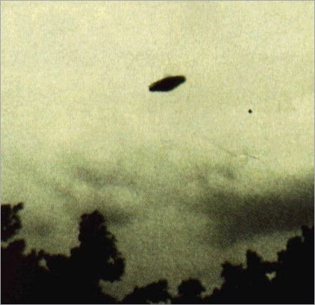
description:
Source:
Original source webpage / article

