1958
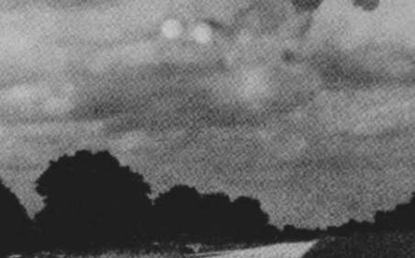
description:
Project Blue Book Files
1958:
Two moving discs were photographed twice by Earl E. Brown, Jr., in 1958. He told Air Force: "they scared the hell out of me."
Source: UFOs at Close Sight (Patrick Gross)
Original source webpage / article

