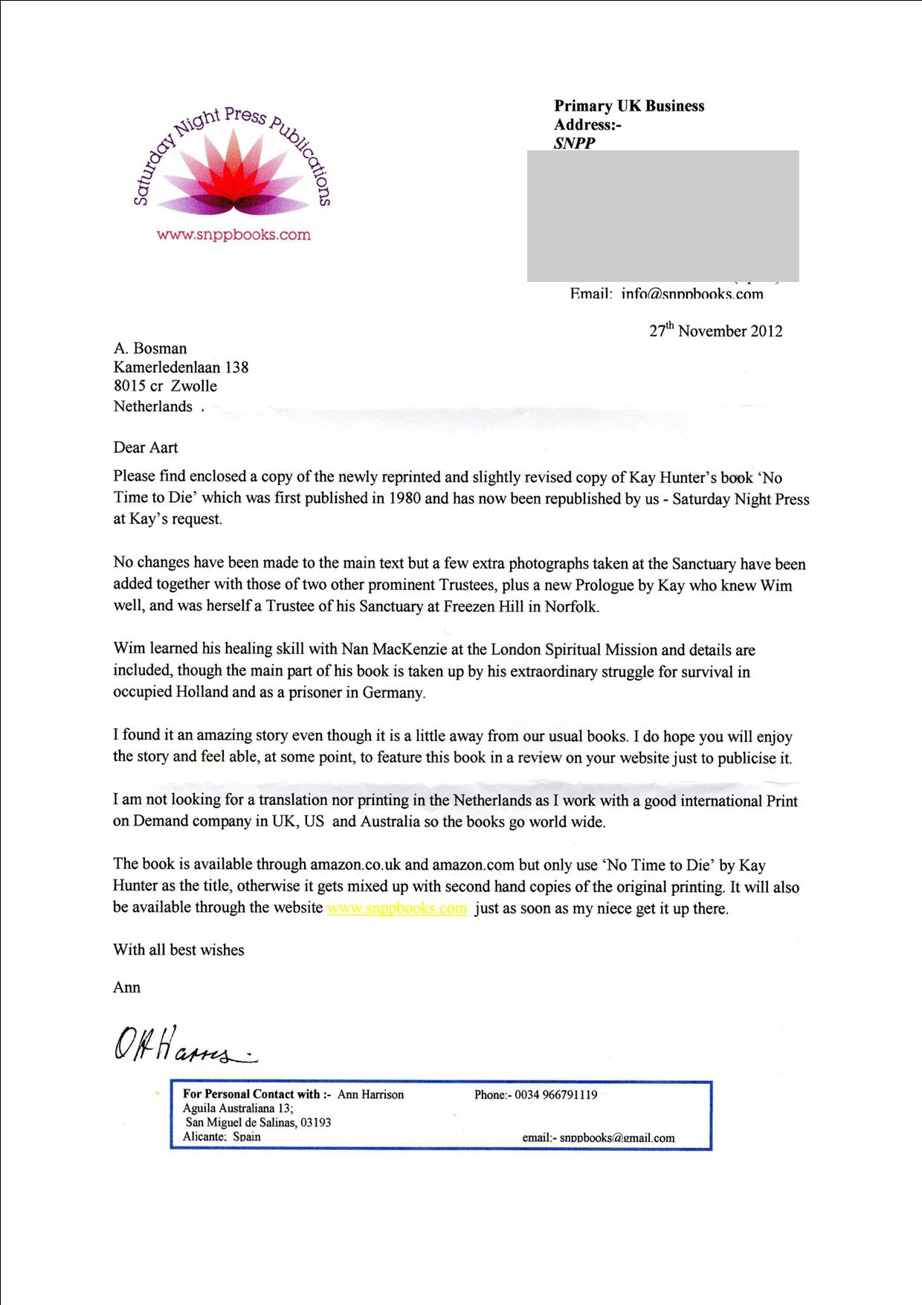

Zwolle 10 December 2012 .

Preview to “ No Time To Die. “
By Aart Bosman .. A man Of 82 . Jan 1 2012 .. .
Who lived in Holland - As well, Under Rotterdam .. And who Himself Survived the Hunger winter of 1944 - With almost No Food - and No heat .
This Book is a great asset to anyone who wants to know more - of what happened - In Holland - during that terrible War.
And who wants to know how anyone could Survive a Concentration Camp ...
Wim Grotenbreg Was such a man Who told his story, In this book.
The war years he spent in Holland was exactly how we lived and, how by fighting against this Evil of the German troups many people survived that War- By the great sacrifice of this very strong and brave man .
But Wim was finally caught, helping the Jews to survive, and was taken to that Concentration Camp Bergen Belzen. And reading his great Story, I am convinced that he Survived - because of His compassion and Love that was much greater than his own craving to survive . .. He stayed alive because , in his mind, was only the will to help others, less strong, less fortunate than Himself. He stayed alive, in this terrible camp only because he never thought of his own self - but only Cared for others .
If you want to know the real truth about those terrible years - Of holocaust - Read this book .
The most emotifull Passage , was when Wim came back from Germany ... And staggered into his Uncle’s house Page 64 . I cried . . for 15 min . . It was so moving to my heart .
And from reading this book I came to Love Wim as a brother, - what A giant of a living Angel he was .. and most likely still is.
He will be one of the first people I’d like to visit in Heaven - when it is my time to go .

You can buy it for a very reasonable price. How you can do that .. please read the letter above .

Wim Grotenbreg Is the most .. Humane and Most remarkable man . I ever read about ..

Aart Bosman . Another Surviver - of those terrible days - Still alive today to write this Review .
Order here:
http://www.amazon.com/No-Time-Die-Grotenbregs-Story/dp/1908421061/ref=pd_rhf_se_p_img

or here snppbooks@email.com or her website www.snppbooks.com

